Test plan for "HUNTED" mobile app.

Introduction 2

1. Test strategy 2

1.1 Scope of testing 2

1.1.1 Feature to be tested 2

1.1.2 Feature not to be tested. 3

1.2 Test type 3

1.3 Risk and issues 4

1.4 Test logistics 4

1.4.1 Who will test? 4

1.4.2 When will the test occur? 4

2. Test objective 4

3. Test criteria 5

3.1 Suspension criteria 5

3. 2 Exit criteria 5

4. Resource planning 5

4.1 System resource 5

4.2 Human resource 5

5. Test environment 6

6. Schedule & estimation 7

6.1 All project tasks and estimation 7

6.2 Schedule to complete these tasks 7

7. Test deliverables 7

7.1 Before the testing phase 7

7.2 During the testing 7

7.3 After the testing cycle is over. 7

# 

# **Introduction**

The mobile app is an [MVP](https://en.wikipedia.org/wiki/Minimum_viable_product) to make communication easier and, you know, more mobile. The app contains only some features of the web app e.g. some chat features, [IAM](https://en.wikipedia.org/wiki/Identity_management), and profile settings.

Test only implemented features and do not create feature/improvement requests for the mobile app as they will be rejected.

# **1. Test strategy**

## 1.1 Scope of testing

### 1.1.1 Feature to be tested

|  |  |  |
| --- | --- | --- |
| Module name | Login type | Description |
| **Sign Up** | Logged out | The user should fill in all empty fields to register like email, password, and repeat password. Available APIs for registration: Google. |
| **Sign In** | Logged in | The user should fill in all empty fields to register like email, password, and repeat password. Available APIs for registration: Google. Below is also the ‘’Don’t have an account? Sign up” link. |
| **Chats** | Logged in | Recruiters should be able to initiate a chat with a candidate on the list of candidates and the candidate profile page. The recruiter should be able to send the offer to the candidate or mark the chat as rejected.  To group chats, candidates and recruiters should have the ability to Archive chats or mark them as Favorite. |
| **My chats** | Logged in | The user can overview his chats. |
| **Candidate profile** | Logged in | In the profile section, the user should be able to:  -Edit his profile.  -Switch between recruiter/user profiles.  -Connect social networks (LinkedIn, GitHub, Google).  -Change password.  Users should be able to activate or deactivate their candidate profile in the profile settings.  Admins should be able to edit user profiles at any time. |
| **Contacts** | Logged in | The user should fill in empty fields as first name, last name, and optional (LinkedIn, Behance, and GitHub) |
| **Preferences** | Logged in | There are users have information about notifications and privacy policy |

### 

### 1.1.2 Feature not to be tested.

These features are not tested because they are not included in the software requirement specs:

-Database

-Hardware Interfaces

-Software Interfaces

-Admin functionality

-Question/feedback form.

## 1.2 Test type

-Security Testing- to check that personal data are safe and will not be transferred anywhere

-Performance Testing- to check how the page works when it is overloaded

-Localization testing- if the app works in a specific location

-Integration Testing- to check if all elements work together

-Smoke Testing- if the most critical functionality works without errors

-Sanity Testing- if would are some bugs, we should check the fixed functionality

-Regression Testing- after fixing new functionality, should be checked if the software works without problems and if no new errors appear after making changes.

## 1.3 Risk and issues

|  |  |
| --- | --- |
| Risk | Mitigation |
| No Wi-Fi internet connection | Try to change the internet with faster data flow, for example on 5G. |
| Testing was interrupted by an incoming call | The best way is to turn on plane mode. |
| The battery ran out and the phone turned off at the most important moment of testing. | The battery should be charged at 100% or the charger should be on the desk. |
| The App loads the Android system too much | The necessary is to change mobile phones from Android to IOS. |

## 1.4 Test logistics

### 1.4.1 Who will test?

Iza Wójs as QA tester and the team of the software development team (business analyst, project manager, developers, QA tester, product designer)

### 1.4.2 When will the test occur?

The tester can start testing when:

-The mobile app is available for testing

-The specific requirements are created

-Creating all the test data and test cases needed

-Creating decomposition

# 2. Test objective

The test objectives are to verify the functionality and API of the Hunted mobile. The testing should be focused on the flow of finding offers, and chats with other members. The main features are authorization, creating an account as a recruiter and candidate, posting a job, finding new job offers, and chatting with candidates or recruiters. Testing should be done on preselected versions of mobile devices described in the "System resource" section.

# 3. Test criteria

### 3.1 Suspension criteria

Whether the team of software testers reports that there are 40-50% of test cases failed or one blocker is detected, suspend testing until the development team fixes all the failed cases.

3.2 Entry criteria

Project requirements, test strategy developed.

### 3.3 Exit criteria

If the software is complete, documentation is created and test execution is finished, testing is completed. When the main test objects are tested and the passed tests are more than 90%, the team can stop testing. The execution rate is mandatory to be 95% unless a clear reason is given.

# 4. Resource planning

## 4.1 System resource

|  |  |  |
| --- | --- | --- |
| No. | Resources | Description |
| 1 | Network | Stable Wi-Fi with the fast speed 10mb/s, 3G/ 5G, Ethernet |
| 2 | Browser | Chrome, Safari, Samsung Internet |
| 3 | OS | Android / IOS |
| 4 | Mobile phone | Samsung, iPhone, Xiaomi, Huawei |

## 4.2 Human resource

|  |  |  |
| --- | --- | --- |
| No. | Member | Tasks |
| 1 | Iza Wójs and the QA team | -Create specific requirements  -Create decomposition  -Define which tests will be performed  -Write test cases  -Create bug reports  -Create a test report |

# 5. Test environment

Testing should be conducted in the production environment. To run the app locally for working we will use Android Studio.

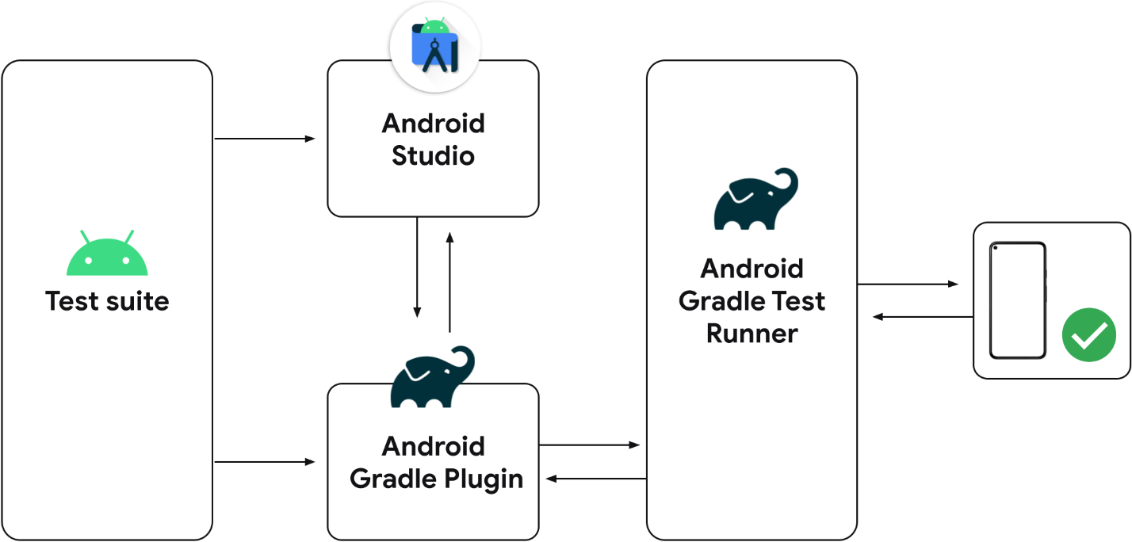

# 

# 6. Schedule & estimation

## 6.1 All project tasks and estimation

|  |  |  |
| --- | --- | --- |
| **Task** | **Members** | **Estimate effort** |
| Specific requirements | Test Designer | 15 man-hour |
| Decomposition | @caty @max @oleh | 2 man-hour |
| Test cases | @izabela @kamil @megan | 5 man-hour |
| Test report | @jay @karl | 12 man-hour |
| Bug Reports | @peter @claudia | 8 man-hour |
| **Summary** |  | **42 man-hours** |

## 6.2 Schedule to complete these tasks

# 7. Test deliverables

## 7.1 Before the testing phase

-Specific requirements for testing

-Document of test cases

-Decomposition of page

-Test data

## 7.2 During the testing

-Error logs

## 7.3 After the testing cycle is over.

-Bug reports

-Test results